**Progress Report-**

**Setup Infrastructure-**

5G environment setup- Open air interface (OAI) is an open-source initiative that provides 3GPP based 5G infrastructure.5G core setup in different levels such as minimal, basic, slice and ULCL. OAI gives two options:  retrieve or build docker images. OAI provides different RAN simulation, that is based on UERANSIM ,GNBSIM and RF SIMULATOR. UPF (user plane function) inside OAI comes with two different flavors (SPGW-U-tiny, VPP-UPF, production grade UPF). OAI can deploy in three different modes, that is Bare-metal based installation or in virtual machines installation, deployment in Docker containers using Docker-Compose, Cloud-native deployment.

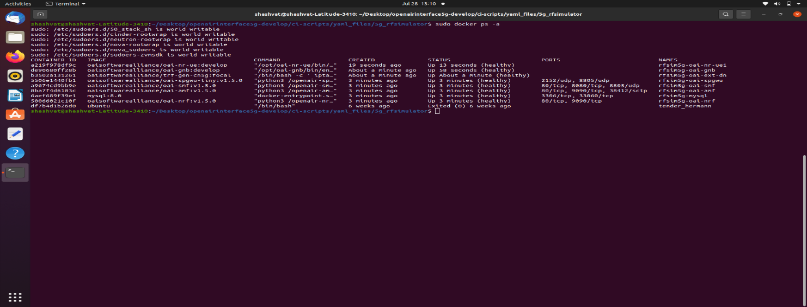

**Figure: 5G infrastructure setup**

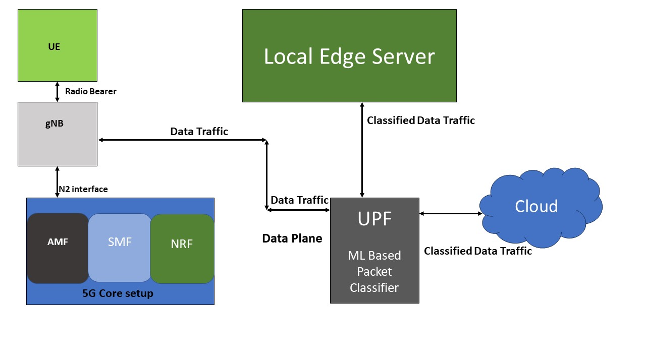

**Figure: Integration architecture**

**UE Setup-** we setup client application inside OAI 5G UE docker which relay data stream for edge or cloud, ML approach applicable to classify data packet.

**Edge server** – we setup local edge server with python flask which receive filter data stream from UPF gateway.

**Packet classifier** -packet classifier set up with UPF inside 5G test bed, it receives data stream from different UE, after receiving data packet it does the classification based on ML approach.

**Table: Entity Deployment**

|  |  |  |
| --- | --- | --- |
| **Name of Entity** | **Development Approach** | **Remarks** |
| Client application | Script of client written with python which focus relay data stream. |  |
| Packet Filter | Packer filter script deploy inside UPF to classify data packets. | We are working to find ML or statistical approach to classify data packets. Script will be on python basis. |
| Edge server /Cloud server | Local server is set up inside VM machine which receive filter data. |  |
| 5G infra | Deployed inside docker container | OAI 5G minimal setup contain following docker entities:  AMF  SMF  UPF  UE  NRF |

**Table: Library in use**

|  |  |
| --- | --- |
| Functionality Name | Approach |
| Data Stream UE to Edge | Python Open cv |
| Edge / cloud server | Flask |
| Network Packet analysis | Pyshark , tcp dump , wireshark |
| Data Classification | Based on ML supervised approach |